**Phase 2 Report: Factors Affecting the Bison Population in South Dakota**

Bisons roamed around North America in millions before the 19th century when they were almost driven to extinction. There have been numerous efforts to restore the bison population, however, only a fraction of them exist around the United States and North America as a whole. We were curious as to what affected the population of Bisons whether that be climate, temperature, or even crop abundance. Over the past two decades, South Dakota has had one of the top Bison populations. This study is investigating the environmental factors that affect the Bison population in South Dakota.

JaeYun took a look at the Bison location data from the [State of Missouri Data Portal](https://data.mo.gov/browse?q=bison&sortBy=relevance). He mapped out the locations of the Missouri Bison State Parks using geopandas, but then realized that there was too little data.

JaeYun then looked at Bison Data from the [United States Geological Survey](https://bison.usgs.gov/#home) database and mapped the geospatial occurrences of Bisons in South Dakota. After noticing that South Dakota had one of the most occurrences in the United States, we decided to look into the Bison inventory per county. 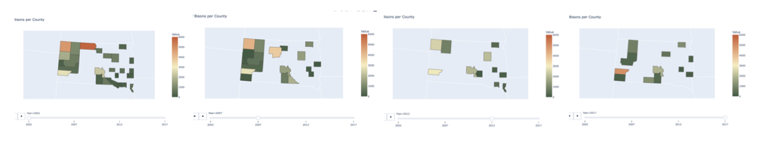

Taylor made a choropleth map from plotly using Bison Inventory data from the [United States Department of Agriculture](https://quickstats.nass.usda.gov/#232A4CE0-1175-36E9-B5B6-4039A8CE41A4). She mapped out the inventory of Bisons over 4 census years. After seeing the variability of color throughout the choropleth map, we wanted to see the actual numbers per county and felt that the best way to visualize it was through a bar graph.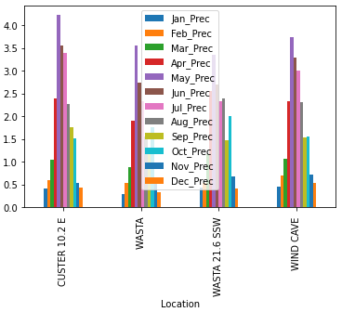

JaeYun directed our team towards comparing the Bison populations with climate data. He used U.S. climate normals data from the <https://ggweather.com/normals/> database to map out the weather in South Dakota. Besides that, he calculated and found the four closest points between Bison data and Climate Normals. Also, JaeYun analyzed the closest four points and compared it with the other points’ average data.

This was JaeYun’s first data science project and throughout the process, he realized that cleaning data was the hardest, but most important aspect. He found that finding datasets was more difficult than he originally thought. He also did some mapping through Python using geopandas and also using GeoDataFrame. By using these techniques JaeYun displayed a map of the United States and marked points from coordinates. Taylor, on the other hand has done some data science projects in the past, but none about a land species and its environment. She also noted that she only had basic knowledge of Python, so this process was a great learning experience. As a group, we faced quite a bit of trial and error, and after computing and analyzing various data, we did not come to any major conclusions. We learned a lot, and are very grateful for all of the help and support that we received along the way.